Profile: EL SALVADOR
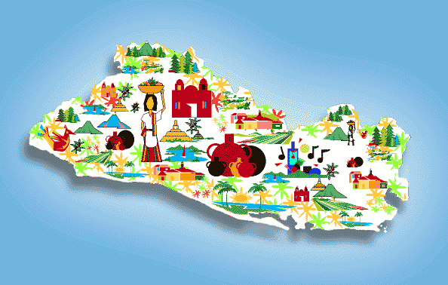

This is a profile of El Salvador. It is the rich culture country in the region of Central America. The GDP of El Salvador is approximately 24.26 billion dollars per year.

Exports | %
Knit T-shirt | 14.24
Coffee | 5.71
Raw Sugar | 3.66
Plastic lips | 3.03
Toilet paper | 2.1

Regional Economies
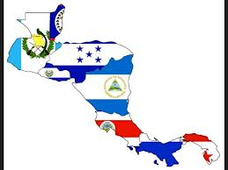
Country | GDP | Main Exports
Costa Rica | 49.52 billion | Integrated circuits, mechanic parts, coffee.
El Salvador | 24.26 billion | Knit T-shirt, coffee, raw sugar.
Honduras | 18.55 billion | Shirts, coffee, bananas.
Nicaragua | 52 billion | Frozen bovine meat, coffee, gold

The regional economy is agriculture and textile. The region is dominated by Guatemala. However, the other countries in the region are strong. El Salvador is between the other countries in exports and GDP.

